WoOOL ToOOLs Usage Guide
WoOOL ToOOLs Usage Guide

Package contents:

Latest version: v2026.03.21.001
CE: Content Editor
ME: Map Editor
MP: Map Patcher
WDaP: WoOOL Download and Patcher

Supported File Types
Supported File Types

WPF variants supported:
- normal .wpf archives with internal FAT
- both primary and legacy header/FAT field layouts
- compressed and uncompressed entries
- zlib-compressed entries in:
  - normal single-stream form
  - newer chunked zlib form
- archives where data is compressed even if the compression flag is missing
- case-insensitive entry lookup

WPF edge cases included:
- If an entry is marked compressed but decompression fails, the code still tries alternate detection before falling back to raw bytes.
- If an entry is not marked compressed, the code still probes for zlib/chunked-zlib and will decode it.
- .wpf.hash sidecars are supported for comparison/info purposes.
- Some WPF entry names may contain non-ASCII bytes; the code tries to work around that internally, but exporting such names can be skipped if the OS path conversion fails.

The SGL reader supports:
- standard indexed .sgl files
- Shanda Game Lib SGL variant ("shanda game lib" header)
- opening from:
  - Disk
  - memory buffers extracted from WPF
- sparse/empty slots (offset = 0) without failing

SGL edge cases included:
- standalone SGL paths are resolved case-insensitively if exact casing is wrong
- WPF-embedded SGLs are loaded fully from extracted memory
- empty slots are valid and simply return no image
- bad/out-of-range indices safely return null/no image rather than crashing

New-format TEX supported;
- standard TEX1
- XOR-obfuscated TEX1 variants where:
- magic is offset from normal TEX1
  - header fields are XOR’d with a small key
  - ??ET-style wrapped/variant headers where the real frame header is not at the standard place

Old-format TEX supported:
- Compression / payload variants supported
- raw uncompressed pixel blocks
- zlib-compressed TEX payloads
- chunked zlib-wrapped TEX payloads
- XET-compressed block payloads
- raw XET DXT payloads

Pixel/block formats supported:
- A8R8G8B8
- A4R4G4B4
- A0R5G6B5
- DXT1
- DXT3
- DXT5

Old TEX option variants handled:
- RLE blocks
- Shanda-style 0x02 size-prefixed RLE behavior
- WoOOL S3TC/DXT blocks
- separate alpha payloads
- newer/unknown 0x60-bit S3TC/DXT variants with size prefixes

Animation is supported, but with safeguards.
Included behaviors:
per-frame decode support
- frame-count detection without fully decoding the image
- invalid frame counts fall back to 1
- truncated or malformed trailing frames are ignored when counting frames
- malformed headers are sanity-checked before trust

Important limit:
In MapEditor, frame counts above a “reasonable” threshold are treated as suspicious and clamped to 1 for stability during preload/render flow.
So:
- shared codec logic can recognize animated TEXs
- MapEditor intentionally becomes conservative for suspicious counts

Content Editor
Content Editor

Setup Data Paths:
Click CONTENT EDITOR in the menu then click Preferences, this will bring up the Settings window.
Click Data Paths header from the left.
Click Add Data Path to add a new row, fill in the Name and Path.
Under Actions clicking … will open a dialog box where you can browse for the folder.
Once set close this window, settings are saved automatically.

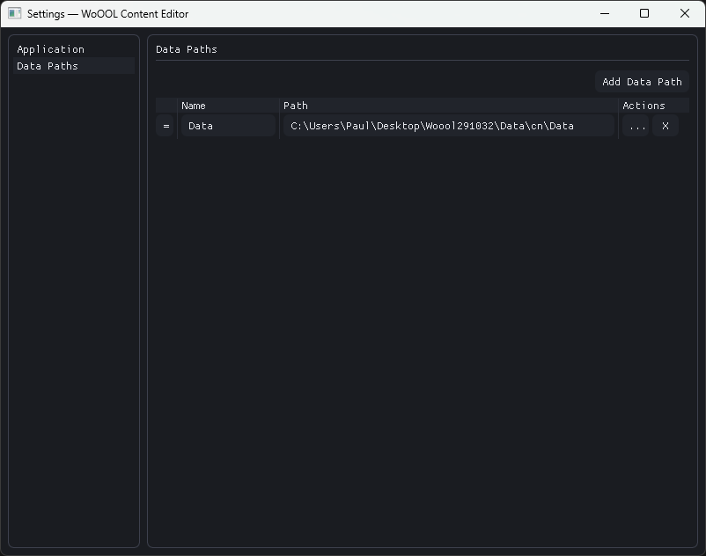
The data folder will appear in the Data Folders panel, one header for each folder specified.

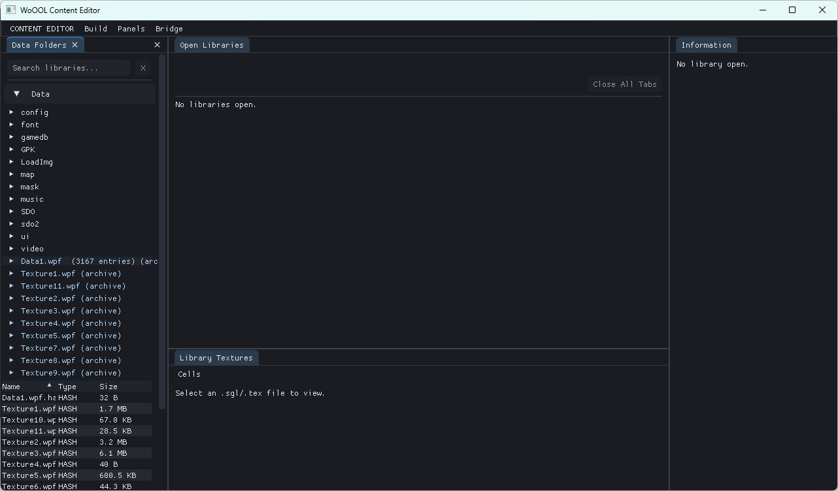
If the Map Editor is open, you can right click a NMP file in the Data Folders panel and open it.
This will send a command to the Map Editor allowing it to read and load the map.
NOTE: The Map Editor needs to be set up with its own data folders first.
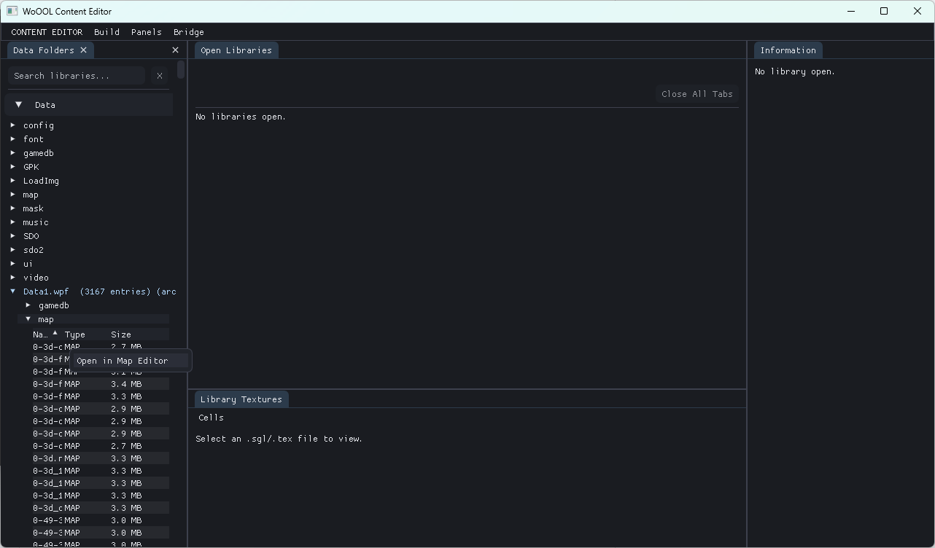
Hash validation and patching:
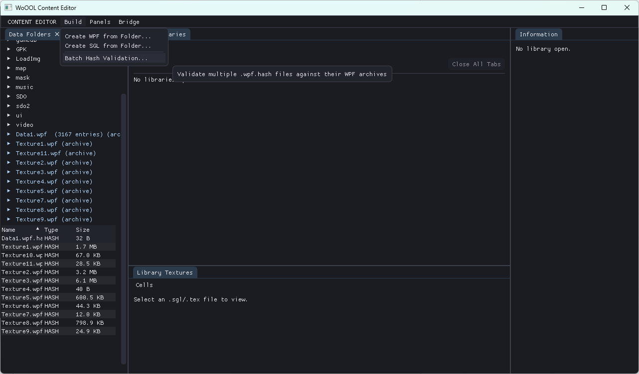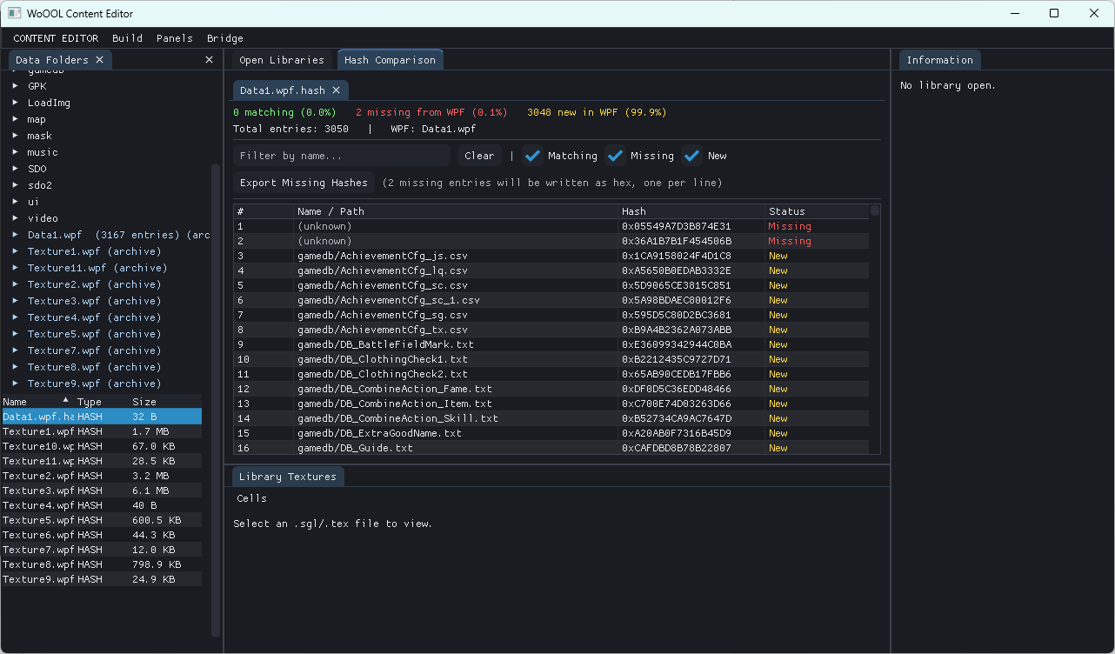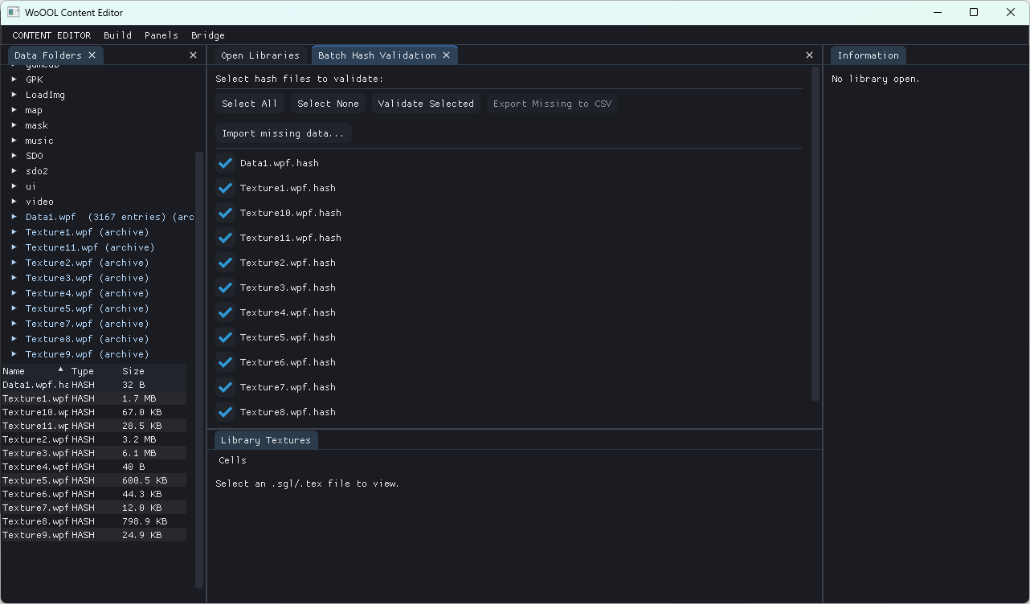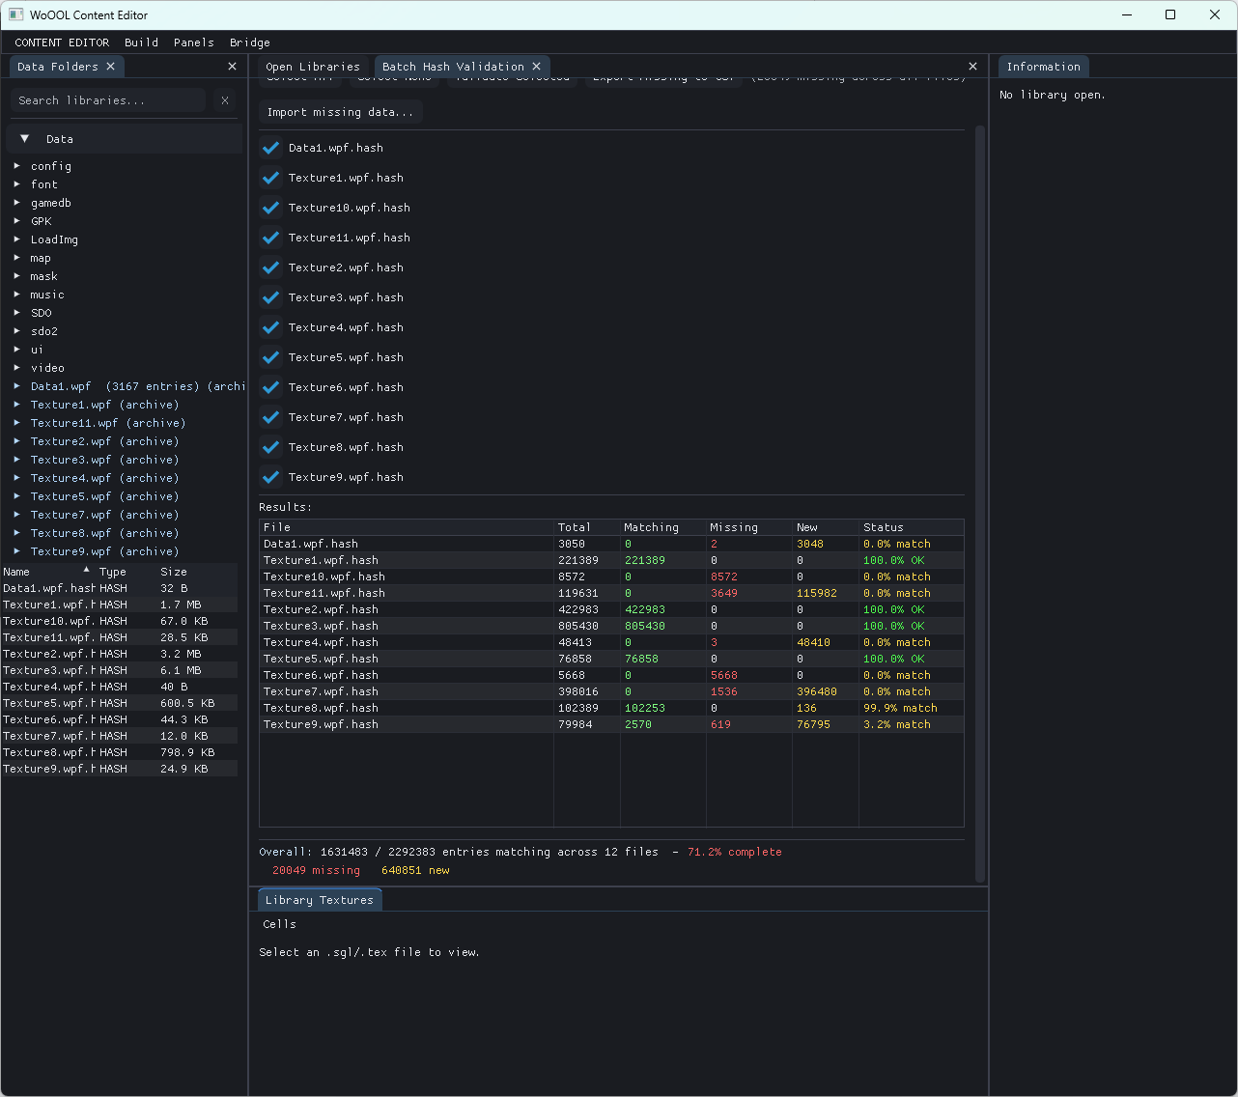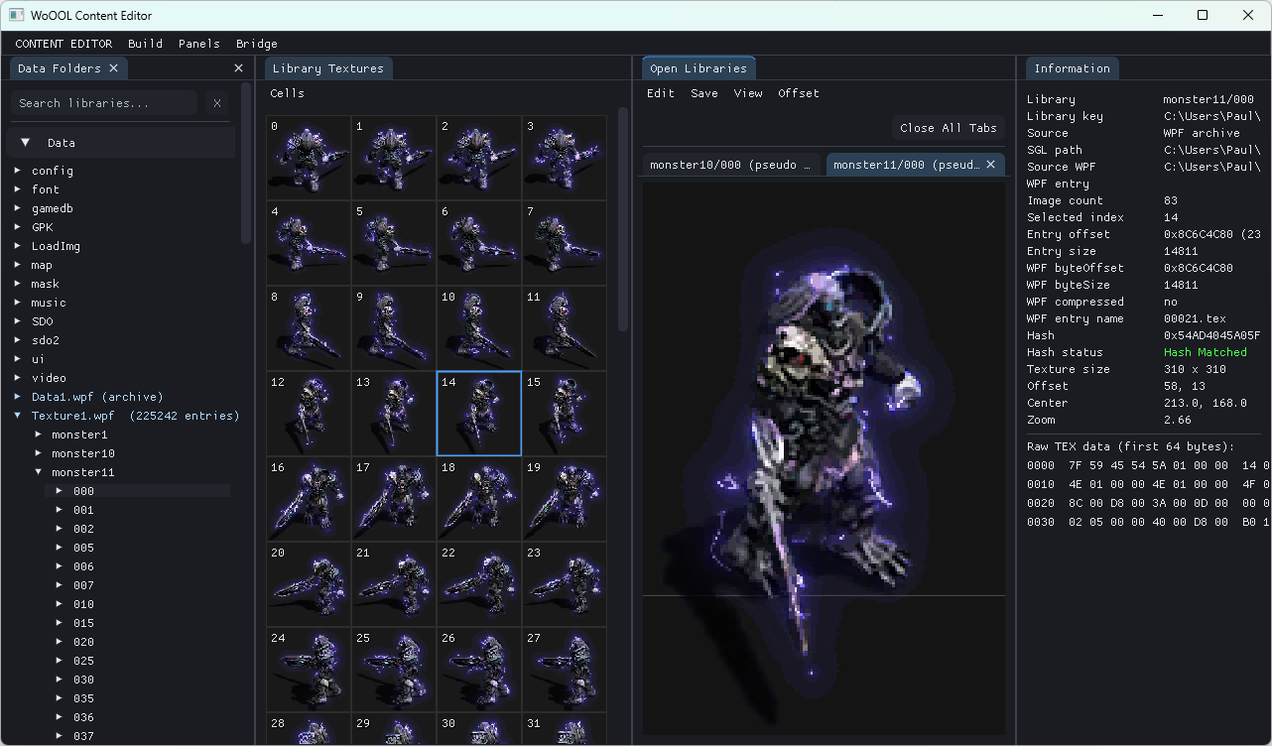

Map Editor

Map Patcher

WoOOL Download Patcher

